 DEPARTMENT OF BOTANY
NATIONAL WORKSHOP ON- (ICFRE) COASTAL ECOSYSTEM CENTRE(CEC)
ISTITUTE OF FOREST BIODIVERSITY MINISTRY OF ENVIRONMENT,
FOREST AND CLIMATE, VISAKHAPATNAM 26-JULY-2025
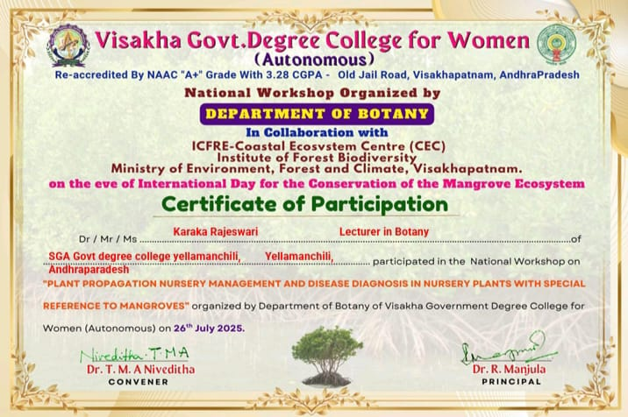

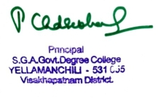
SIGNATURE OF LECTURER SIGNATURE OF PRINCIPAL

